PF Lab Task 9

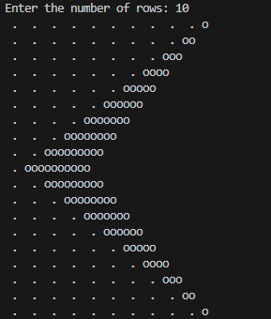

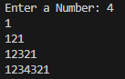

Q3) 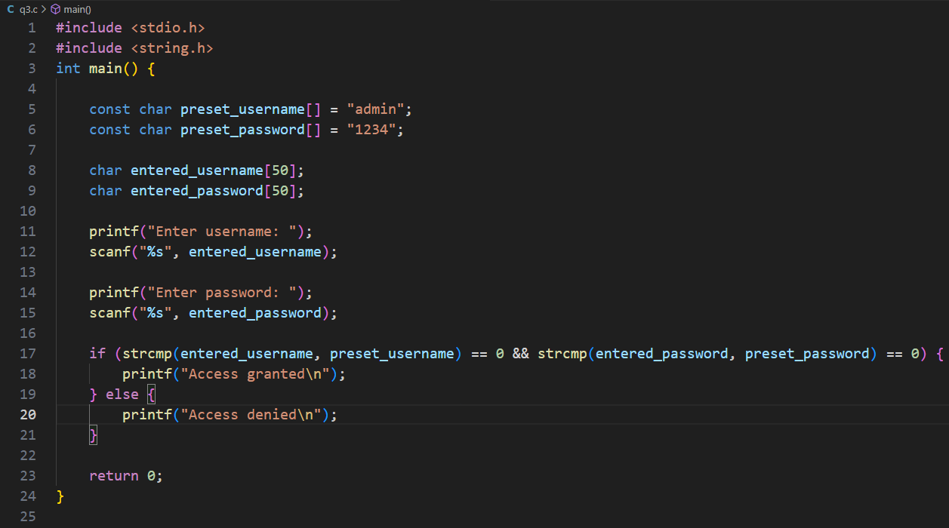

Q4) 